Name: Madhu Balan I
Reg no:192321142
Course: Computer Vision

CO5 ASSESSMENT 2
PSEUDOCODE WRITING TASK
Detailed OpenCV-oriented algorithms for real-time face recognition and vehicle monitoring.
1. Real-Time Face Detection and Recognition
Question: A security system must process a live camera stream, detect multiple faces, recognise registered persons using a trained dataset, display bounding boxes and identity labels, operate in real time, minimise processing delay, and handle multiple faces simultaneously. Write detailed pseudocode for the complete OpenCV-based pipeline, including acquisition, preprocessing, detection, feature extraction, recognition, visualisation, and efficient loop control.
Answer:
The algorithm below uses a staged pipeline. It loads the camera and trained models once, processes each frame, detects all faces, extracts an embedding or feature vector for every acceptable face, matches each feature vector with the registered gallery, and displays the result. The recognition decision is deliberately thresholded: when the best match is not sufficiently reliable, the label is “Unknown” rather than an arbitrary registered person.
Before the live loop starts, the registered dataset is converted into a searchable gallery. Each person should have several images captured under different expressions and lighting conditions. The enrolment stage detects and aligns a face in each image, extracts a feature vector, normalises it, and stores the person’s name with the vector. Averaging several normalised vectors can reduce sensitivity to one unusual photograph. The gallery and the neural-network or cascade models should be loaded only once to avoid repeated initialisation overhead.
Inside the loop, frames are captured continuously and optionally resized. Mild brightness normalisation and denoising improve detection in difficult illumination, but the system should reject very blurred or very small faces before recognition. A DNN face detector is more robust to pose than a basic Haar cascade, while a Haar cascade can be used on very limited hardware. Non-maximum suppression prevents multiple overlapping boxes from producing duplicate face entries.
For every detected face, alignment based on eye landmarks makes the input orientation more consistent. The feature extractor produces a numerical embedding. Recognition compares the embedding with the registered gallery using cosine distance or Euclidean distance. The nearest candidate is accepted only if its distance is below a calibrated threshold and, where used, the gap between the best and second-best candidate is large enough. A short temporal confirmation rule, such as requiring two or three consistent observations, can reduce one-frame false matches.
Loop efficiency is achieved by processing a reduced frame size, limiting the region of interest, detecting every second or third frame, and tracking faces between detection frames. The capture and display operations can run in separate threads, while a bounded queue prevents unlimited latency. The loop exits when the user presses a configured key or when the capture device fails. Resources are released with cap.release() and cv2.destroyAllWindows().
INITIALISE camera ← cv2.VideoCapture(0)
LOAD face_detector, landmark_model, feature_model
LOAD registered_gallery[name] = normalised feature vectors
SET frame_index ← 0, detection_interval ← 2, quit_key ← ESC
WHILE camera is open:
success, frame ← camera.read()
IF success is FALSE: BREAK
frame_index ← frame_index + 1
display_frame ← copy(frame)
IF frame_index MOD detection_interval ≠ 0 AND tracks exist:
UPDATE face tracks using tracker prediction
DRAW current track boxes and labels
SHOW display_frame
IF waitKey(1) = quit_key: BREAK
CONTINUE
small_frame ← resize(frame, target_width)
clean_frame ← normalise_brightness_and_denoise(small_frame)
face_boxes ← face_detector.detect(clean_frame)
face_boxes ← non_maximum_suppression(face_boxes)
FOR each box IN face_boxes:
crop ← crop_face(clean_frame, box)
IF quality(crop) < minimum_quality: label ← "Low quality"; CONTINUE
aligned ← align_using_landmarks(crop, landmark_model)
vector ← normalise(feature_model.extract(aligned))
best_name, best_distance ← nearest_gallery_match(vector, registered_gallery)
IF best_distance < recognition_threshold:
label ← best_name
ELSE:
label ← "Unknown"
UPDATE temporal_confirmation_for_track(box, label, best_distance)
DRAW rectangle and confirmed label on display_frame
SHOW display_frame
key ← waitKey(1)
IF key = quit_key: BREAK
RELEASE camera; DESTROY windows
Component | Purpose | Efficiency or accuracy control
Camera acquisition | Read live frames | Capture thread and bounded queue
Preprocessing | Improve input consistency | Resize, luminance correction, mild denoise
Face detector | Find all candidate faces | DNN or Haar; NMS; ROI
Feature extractor | Convert face to numerical representation | Alignment and normalisation
Recognition | Assign identity or Unknown | Distance threshold and margin
Loop control | Maintain responsiveness | Frame skipping, tracker, ESC exit

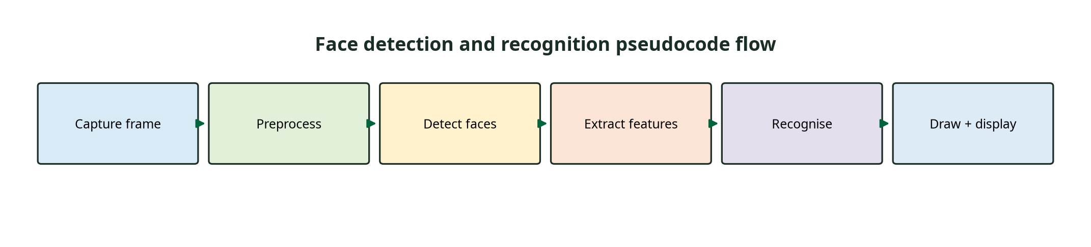
Figure 1. The pseudocode flow from camera acquisition to labelled face display.

2. Vehicle Detection, Tracking and Counting
Question: A traffic-monitoring system must detect vehicles entering a predefined region of interest, track multiple vehicles across consecutive frames, count vehicles crossing a virtual line, display bounding boxes and tracking IDs, avoid double counting, handle multiple vehicles, maintain near real-time performance, and terminate efficiently. Write detailed pseudocode for the complete OpenCV-based solution.
Answer:
The vehicle algorithm is event-based: a vehicle is counted only when a confirmed track crosses the virtual line in the required direction. It does not count foreground blobs directly and does not add one count per frame. This design is essential because a vehicle remains visible for many frames and would otherwise be counted repeatedly.
The system first opens the video source and defines the road region of interest and the counting line. Preprocessing can reduce noise with a small blur, while background subtraction or a lightweight object detector generates vehicle candidates. Background subtraction is useful for a fixed camera, but detector confirmation is important when shadows, reflections, stopped vehicles, or dynamic backgrounds create misleading foreground regions. Morphological opening and closing clean the candidate mask before contours are extracted.
Every accepted detection contains a bounding box, centroid, class label, and confidence. The tracker maintains a dictionary of active tracks. Each track stores a unique ID, the most recent centroid, bounding box, trajectory history, number of consecutive observations, number of missed frames, and a crossed flag. Detections are associated with tracks using intersection-over-union, centroid distance, and predicted motion. A simple centroid tracker is suitable for a basic implementation; a Kalman filter and assignment step improve performance when vehicles overlap.
Line crossing is determined with the signed position of a centroid relative to the virtual line. When the previous signed position and the current signed position have opposite signs, the track crossed the line. The event is accepted only when the direction agrees with the configured travel direction, the track is confirmed, and crossed is false. The crossed flag is then set to true, so the same track cannot increment the count again. A short lost-track timeout allows a vehicle to disappear briefly without immediately creating a new ID.
The display overlays the region of interest, virtual line, bounding boxes, IDs, trajectories, vehicle count, and alerts. The loop terminates when the video ends, the camera fails, or the user presses ESC or q. At termination, the system releases the capture device, closes windows, and can save the count and event log. Frame skipping and tracking between detector calls help keep the system near real time.
INITIALISE camera ← cv2.VideoCapture(video_source)
DEFINE ROI_polygon and counting_line; SET permitted_direction
LOAD vehicle_detector or background_subtractor
INITIALISE tracks ← empty map, next_id ← 0, vehicle_count ← 0
WHILE camera is open:
success, frame ← camera.read()
IF success is FALSE: BREAK
roi_frame ← mask_to_region_of_interest(frame, ROI_polygon)
clean_frame ← denoise(roi_frame)
raw_detections ← vehicle_detector.detect(clean_frame)
IF using_background_subtraction:
foreground ← subtract_background(clean_frame)
foreground ← morphological_open_and_close(foreground)
candidates ← contours_to_boxes(foreground)
detections ← validate_with_vehicle_class_or_shape(candidates)
ELSE:
detections ← filter_by_confidence_and_class(raw_detections)
predictions ← predict_existing_tracks(tracks)
assignments ← associate(detections, predictions, IoU_and_distance_rules)
FOR each matched detection and track:
UPDATE track box, centroid, history, confidence, missed_frames ← 0
IF track is not confirmed AND observations ≥ confirmation_frames:
track.confirmed ← TRUE
previous_side ← signed_distance(track.previous_centroid, counting_line)
current_side ← signed_distance(track.centroid, counting_line)
IF track.confirmed AND NOT track.crossed AND sides_have_opposite_sign:
IF direction_matches(previous_centroid, centroid, permitted_direction):
vehicle_count ← vehicle_count + 1
track.crossed ← TRUE
LOG time, track.id, direction, confidence
FOR each unmatched track: track.missed_frames ← track.missed_frames + 1
DELETE tracks whose missed_frames > max_missed_frames
CREATE new tentative tracks for unmatched valid detections; increment next_id
DRAW ROI, counting line, boxes, IDs, trajectories, count, and alerts
SHOW frame
key ← waitKey(1)
IF key = ESC OR key = q: BREAK
RELEASE camera; DESTROY windows; SAVE event log
Stage | Pseudocode responsibility | How double counting is prevented
Detection | Generate vehicle boxes | Uses candidates only as inputs to tracks
Association | Match boxes to existing IDs | Preserves identity between frames
Confirmation | Require persistent observations | Rejects one-frame noise
Crossing test | Compare previous/current line sides | Recognises a real crossing event
Count update | Increment only if crossed = false | One count per track
Track cleanup | Remove stale tracks after timeout | Prevents indefinite memory growth

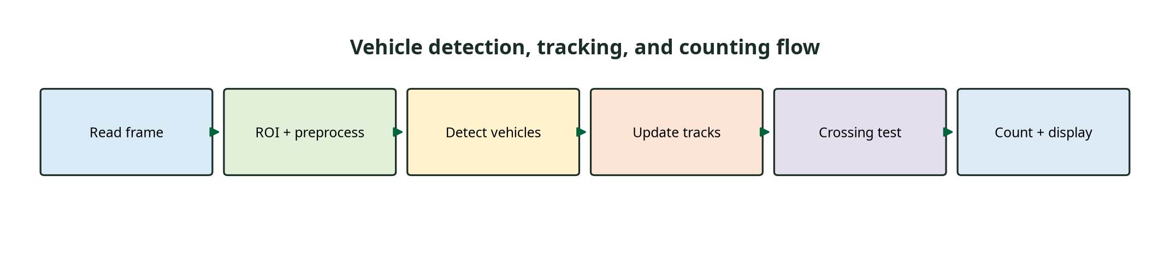
Figure 2. The pseudocode flow for detection, multi-object tracking, line-crossing logic, and display.
Implementation and Testing Notes
Answer:
The pseudocode is intentionally language-independent, but each operation maps to common OpenCV functions. cv2.VideoCapture handles acquisition; cv2.resize, cv2.cvtColor, and filtering support preprocessing; cv2.dnn or a cascade performs detection; cv2.findContours supports mask-based candidate extraction; cv2.rectangle, cv2.putText, and cv2.line create the visual overlay; and cv2.waitKey controls efficient loop termination. A production implementation would add structured logging, exception handling, camera reconnection, and configuration files for thresholds rather than embedding every value in the source code.
Both systems should be tested using representative video rather than a single demonstration. For face recognition, measure detection recall, false-accept rate, false-reject rate, recognition latency, and unknown-person handling. For traffic monitoring, measure count error, missed vehicles, false counts, ID switches, line-crossing event precision, and frame rate. Profiling should identify whether detection, feature extraction, association, or display is the bottleneck. Optimisation should then target the measured bottleneck without weakening the confidence and temporal checks that protect accuracy.

